**KWAME NKRUMAH UNIVERSITY OF SCIENCE AND TECHNOLOGY**



**COLLEGE OF ENGINEERING**

**DEPARTMENT OF CHEMICAL ENGINEERING**

**ENGINEERING IN SOCIETY (CENG 291)**

**WASTE OF HUMAN HAIR BY BARBERS IN SAKI**

**NAME: AMEZUWEH GIDEON**

**INDEX NUMBER: 5994616**

**AUGUST 2016**

# ACKNOWLEDGEMENT

With so much joy, I would like to show my heartfelt gratitude to God for leading me throughout the entire process, then to my supervisor, Madam Ella Kwao-Boateng, for approving this case study, to Mr. Brown (a barber) for his massive support in providing some basic information about the topic, to Mr. John Alhassan for his unfailing support in considering this study, then to Joseph Annor-Gyamfi for his creative ideas in making this work a success. Again, to all friends and family relations who guided me in putting together this piece. May the Good Lord who is Himself the Rewarder of all good deed grant you many blessings that you cannot fathom.

# ABSRTRACT

The Human hair is considered a waste material in most parts of the world and its accumulation in waste streams causes many environmental problems; however, it has many known uses. Preventing waste of such a material requires both addressing the problems in the current usage and developing its utilization systems at locations where they are missing. With focus on developing systematic utilization of human hair waste, this paper first reviews the possible uses of human hair gathered from large scale trades, local/traditional knowledge, upcoming innovations, and scientific research; along with the socioeconomic systems that have evolved around the known uses. Concerns and gaps in these systems are identified and possible directions to address these gaps are discussed. For expanding hair utilization to new contexts, important considerations such as knowledge, skill, and technology requirements and potential markets are discussed.

Finally, a policy framework for socially and environmentally healthy utilization of human hair is outlined. This study shows that human hair is a highly versatile material with significant potential in several critical areas such as agriculture, medical applications, construction materials, and pollution control. Moreover, these uses are diverse enough for entrepreneurs ranging from unskilled to highly technical individuals and for the wide variety of human hair waste available in different locations which include saki.

# CHAPTER ONE

## INTRODUCTION

### BACKGROUNG TO THE COURSE

#### 1.1.1 CENG 291

In general, Engineering in society is one course that encompasses skill development and problem solving processes. The overall aim of this course is to inculcate in the students an appreciation of the fact that the purpose of engineering is to solve societal problems. The course is aimed at encouraging students early in their programs of study to draw a link between their chosen field of engineering and the application of this field to the issues that confront the day-to-day lives of people and to the country at large.

#### 1.1.2 CHEMICAL ENGINEERING AS A FIELD OF STUDY

*Chemical engineering* is a branch of engineering that applies physical sciences (physics and chemistry), life sciences (microbiology and biochemistry), together with applied mathematics and economics to produce, transform, transport, and properly use chemicals, materials and energy. A chemical engineer designs large-scale processes that convert chemicals, raw materials, living cells, microorganisms and energy into useful forms and products. This involves recycling of products for use by man.

#### 1.1.3 PROJECT

The topic under study is ***waste of the human hair by barbers in saki***. This embodies a better approach for the use of human hair rather burning and treating as waste by most barbers in the community.

### AIMS AND OBJECTIVES

To identify several ways the human hair is being wasted in the society, to identify several ways to put the human hair to use and to consider a more convenient use of the human hair to favor the need of my Society.

# CHAPTER TWO

## MAERIALS AND METHODS

### 2.1 METHODOLOGY

Besides available literature, data on human hair uses was collected through intensive field studies involving several target groups: barbers, some waste pickers and the general public. The studies were conducted through informal discussions with the target group members from golf city, high tension, E. T Wussah street, Aben woha locality, bediako locality through to Gyenyame junction in Saki during June 2017 to August 2017. Hair traders were also contacted, but they were generally quite reluctant to discuss details of the trade.

The data on the actual use of shaved hair by barbers were collected as well as that on the average number of people who shave at those shops. The authenticity of information obtained through field discussions was cross-checked with people from different geographical locations as well as other available sources, and the same was attempted for data obtained from news and internet articles.

Day after day, these target areas were visited to verify any information provided so as to authenticate any finding. It was discovered again that some barbers of interest use to be busy almost always, either with shaving or chatting with some colleagues which sometimes made it somewhat difficult to gain their full attention. Some observers around the target areas provided some information on the burning of the shaved hair right behind their stores which added to the verification of the various findings.

### 2.2 MAP PREPARATION

The map was prepared with the use of the GPS location since Saki is located in the Kpone district, Tema municipality. And special Land marks identified with the help of a topographic sheet provided by the District Assembly, and with the help of some indigenes of Saki.

### 2.3 DATA COLLECTION

A lot of time and energy was sacrificed in this area, this include questionnaire preparation, interviews, unannounced visits to various target areas, etc.

#### 2.3.1 QUESTIONAIRES

Questionnaires were sent out to target areas to be well informed about the act of the barbers. A questionnaire which involves issues like, what do you use the hair for after shaving them? How many customers do you get on an average day? Etc. was asked in order to make informed choices on the matter.

#### 2.3.2 INTERVIEWS

Various interviews were conducted on a variety of barbering shops to find out more about the reality. More importantly, this activity was carried out in order to collect data on number of people who shave their hair per day and the actual use of the shaved hair after a day’s work. This aspect became so necessary because some were illiterates.

#### 2.3.3 UNNANOUNCED VISITS

This very activity made the data collection so authentic that I became an eye witness to every bit of information gathered during the interviews. I went to various barbering shops at target times of the day to verify my findings. People around those shops were engaged for same purpose, and then I observed from a distance the number of people who come to shave their hair on some chosen days for some chosen shops.

|  |  |  |
| --- | --- | --- |
| Barbers shop | Numbers of people per day | Average mass of human hair per day |
| A | 15 | 90g |
| B | 13 | 78g |
| C | 5 | 3og |
| D | 8 | 48g |
| E | 11 | 66g |
| TOTAL | 52 | 312g |

# CHAPTER THREE

## RESULT AND DISCUSSION

### 3.1 DISCRIPTION OF THE COMMUNITY

#### 3.1.1 THE MAP OF SAKI, TEMA

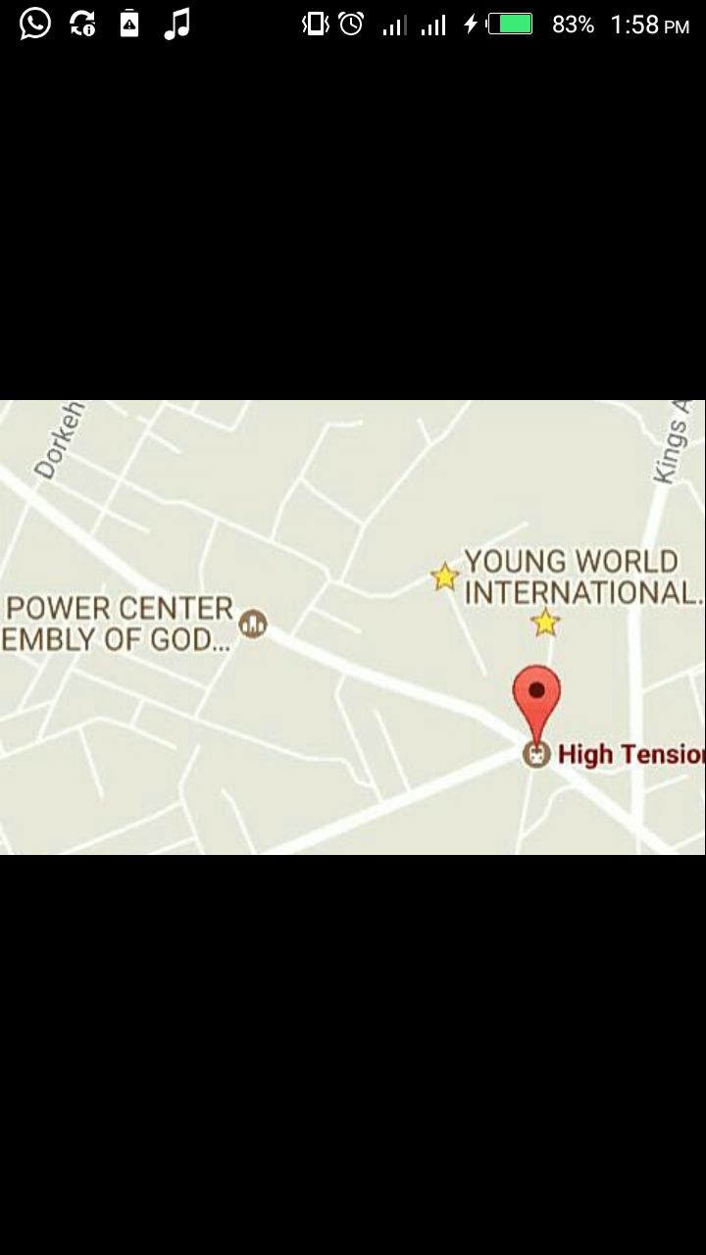

Fig 3.1a

#### 3.1.2 LOCATION

Saki is located in Tema, in the Greater Accra region of Ghana. Its surrounding neighbours are Ashaiman, Tema community 25, Tema community 22, Kpone and Dorwenya. It is 35 km away from the capital of Ghana, Accra.

#### 3.1.3 GEOGRAPHY

The topography of saki is flat, it is locate at a latitude of 5. 7227o North and a Latitude of 0.0033o East.

#### 3.1.4 GOVERNMENT

Saki is in the kpone Katamanso constituency in the greater Accra region of Ghana and is being represented by Honorable Joseph Nii Larye Afortey- Agbo. He traditional chief of Saki is Nii Tetteh Oglie II.

#### 3.1.5 OCCUPATION

Most of the the people in Saki are farmers and some are traders, out of which are Barbers.

#### 3.1.6 SETTING AND HISTORY

SAKI is a suburb of Tema municipality, Tema is a city on the Golf of Guinea and atlantic coast of Ghana. It is locatd 25 kilometres (16 mi) east of the capital city; Accra, in the region of Greaer Accra, and is the capital of Tema Metropolitan District. Asof 2013, tema was the eleventh most populous settlement in Ghana with a population of approximately 161,612 people- a marked decrease from its 2005 figure of 209, 000. The Greenwich meridian (00 longitude) passes directly through the city.

### 3.2 NATURE AND CHARACTERISICS OF THE PROBLEM.

#### 3.2.1 THE HUMA HAIR

3.2.1.1 Structure of the human hair

The human hair is simple in structure, but has important functions in social functioning. Hair is made of a tough protein called keratin. A hair follicle anchors each hair into the skin. The hair bulb forms the base of the hair follicle. In the hair bulb, living cells divide and grow to build the hair shaft. Blood vessels nourish the cells in the hair bulb, and deliver hormones that modify hair growth and structure at different times of life.

Real structure.

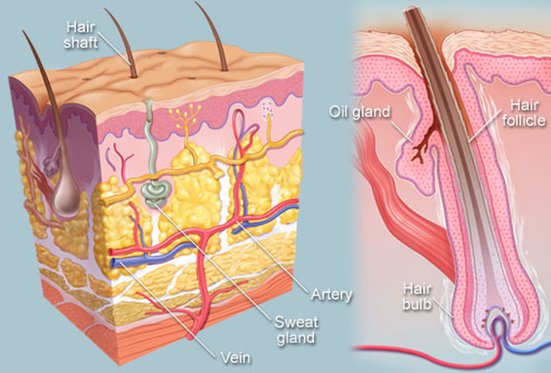

Chemical structure

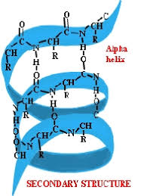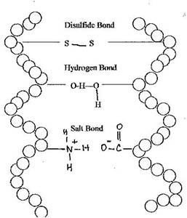

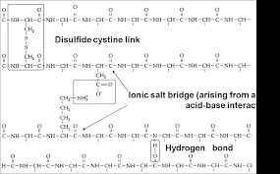

##### 3.2.1.2 How the human hair grows

Hair growth occurs in cycles consisting of three phases:

* *Anagen* (growth phase): Most hair is growing at any given time. Each hair spends several years in this phase.
* *Catagen* (transitional phase): Over a few weeks, hair growth slows and the hair follicle shrinks.
* *Telogen* (resting phase): Over months, hair growth stops and the old hair detaches from the hair follicle. A new hair begins the growth phase, pushing the old hair out.

Hair grows at different rates in different people; the average rate is around one-half inch per month. Hair color is created by pigment cells producing melanin in the hair follicle. With aging, pigment cells die, and hair turns gray.

##### 3.2.1.3 Hair Conditions

* ***Alopecia areata***: Round patches of total hair loss, usually from the scalp. The cause of alopecia is unknown; the hair usually grows back.
* ***Male pattern baldness***: The most common type of hair loss in men. Male pattern baldness usually includes either a receding hairline, hair loss at the crown, or both.
* ***Female pattern baldness***: In women, hair loss usually includes uniform thinning across the scalp, with a preserved hairline. The crown may be affected, but hair loss rarely proceeds to baldness as in men. See a picture of female pattern baldness.
* ***Dandruff*** (seborrheic dermatitis): Ongoing mild inflammation of the scalp, resulting in scaly skin that may be itchy and flake off. Seborrheic dermatitis may also affect the ears and face.
* ***Tinea capitis***(ringworm): A fungal infection of the scalp, creating round patches of hair loss. Although the patches can appear in a ring shape, no worm is involved in tinea capitis.
* ***Trichotillomania***: A mental disorder that includes the irresistible urge to pull out one's hair. The hair pulling results in patches of noticeable hair loss; its cause is unknown.
* ***Head lice***: Tiny insects that live on the scalp and feed on blood. Preschool and elementary school-aged children and adults who live with children are most susceptible to catching head lice, which are only spread through close contact.
* ***Telogen effluvium***: A month or two after a personal shock (such as surgery, childbirth, severe stress), hair can abruptly fall out in large patches. Typically, new hair starts regrowing right away.
* Postpartum alopecia- hair loss after delivering a baby- is a form of telogen effluvium and usually resolves without treatment.
* ***Folliculitis***: Inflammation of hair follicles, usually due to an infection. *Staphylococcus aureus* is a bacteria that frequently causes folliculitis. Acne is a form of folliculitis that is caused by inflammation. This inflammation can sometimes be worsened by the bacteria Propionibacterium acnes.
* ***Piedra*** (trichomycosis nodularis): Fungal infection of the hair shaft. Hard nodules made of fungus cling to hair fibers, sometimes causing hair loss.
* ***Hirsutism***: A condition in which women develop male-pattern hair (such as facial hair). An excess of testosterone due to a medical condition is usually responsible.

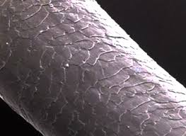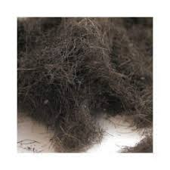  
 fig.1 shaved hair fig.2 microscopic view of one

##### 3.2.1.4 Hair Tests

* ***Hair DNA testing***: Hair follicles contain DNA; hair can be tested to establish paternity or as evidence in a crime investigation.
* Hair drug testing: Many street drugs (or their breakdown products in the body) are absorbed into the hair. A sample of hair can be tested for recent drug use.
* ***Hair analysis***: Testing of hair for toxic exposures, such as lead or mercury poisoning. These tests are limited by inconsistency and difficulty interpreting their results.

##### 3.2.1.5 Hair Treatments

* ***Minoxidil*** (Rogaine): A medicine applied to the scalp, which can help prevent hair loss in most people when used daily.
* ***Finasteride*** (Propecia): A medicine for men taken in pill form daily, which regrows some hair and prevents hair loss in most men who use it.
* ***Hair transplants***: Surgery to remove skin and hair from the back of the scalp, and transplant groups of hair follicles to areas of thin hair.
* ***Hair electrolysis***: A very fine needle is inserted into a hair follicle, and electrical current is applied. The electricity destroys the follicle, preventing hair growth.
* ***Laser hair removal***: A laser is aimed at the cells in the hair follicle, and the laser's high energy destroys cells there, preventing hair growth

#### 3.2.2 BARBERS AND THEIR SHOPS IN THE SAKI

About 16 barbering shops with each a barber was recorded, this alone is a faire indication that the job is on the rise. Indigenes as well as strangers from far and near usually go to these shops for shaving.

The table below shows some various shops and ways in which they waste the shaved hair;

|  |  |
| --- | --- |
| Waste method | BARBERING SHOPS |
| Burn | 11 |
| Dump in dust bins | 5 |
| Bury | 1 |

Below is a pictorial view of how onebarbering shop looks like;



Fig 1 fig 2

#### 3.2.3 ACTUAL PROBLEM

The actual problem is about how shaved hair is treated after it have been cut. This issue goes beyond what means it is kept rather it looks at what is used for.

Human hair is a material considered useless in Saki and therefore is found in the municipal waste streams in almost any junction. Especially, at High tension and areas with low population density like Aden woha street, Bediako and Golf city.

* HUMAN HAIR BEING THROWN AWAY

The hair is thrown away in nature where it slowly decomposes over several years, eventually returning the constituent elements, namely, carbon, nitrogen, sulfur, and so forth, to their respective natural cycles. In urban areas or areas with high population density,

Effect on the environment:

It often accumulates in large amounts in the solid waste streams and chokes the drainage systems, posing a multifaceted problem. Due to slow degradation, it stays in the dumps/waste streams for long occupying large volumes of space. Over time, leachate from these dumps increases the nitrogen concentration in the water bodies, causing problems of eutrophication.

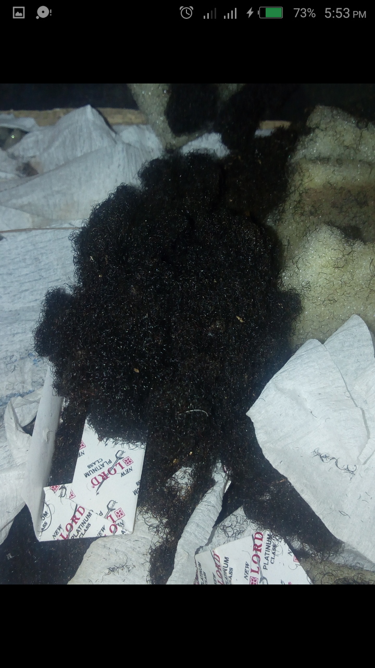

* BURNING OF THE HUMAN HAIR

Burning of human hair or the waste piles containing them—a practice observed in many sub- localities of Saki —produces foul odor and toxic gases such as ammonia, carbonyl sulphides, hydrogen sulphides, sulphur dioxide, phenols, nitriles, pyrroles, and pyridines .

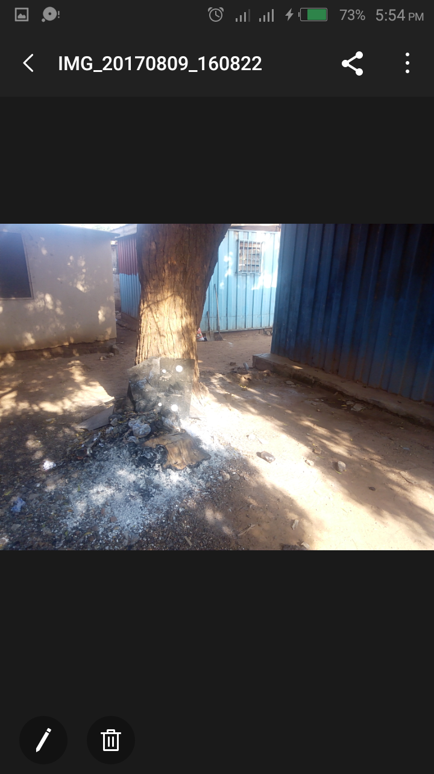

* HUMAN HAIR IN OPEN DUMP

Open dumps of hair generate hair dust which causes discomfort to people near them and, if inhaled in large amounts, can result in several respiratory problems. Oils, sweat, and other organic matter sticking to the hair rot over time and become a source of foul odor and breeding ground for pathogens.

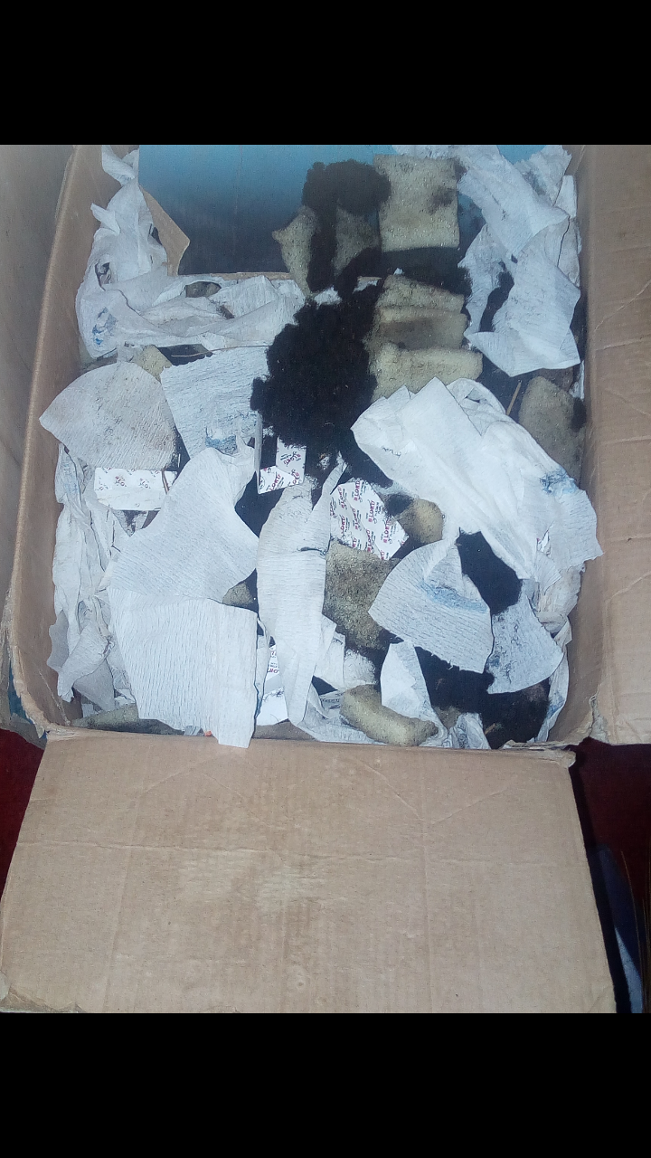

* BURRYING OF HUMAN HAIR

When the human hair is buried by barbers, it is not always safe as it decomposes quite slower yet retains is nutritional content hence rodents and some pests may dig tunnels to reach and feed on them. They get exposed again and pose a lot of treats to the environment. These include air pollution since the halve rotten decaying matter would release foul and various pungent smelling gases like ammonia into the atmosphere.

# CHAPTER FOUR

## CHEMICAL ENGINEERING

### 4.1 AS A FIELD OF ENGINEERING

*Chemical engineering* is a branch of engineering that applies physical sciences (physics and chemistry), life sciences (microbiology and biochemistry), together with applied mathematics and economics to produce, transform, transport, and properly use chemicals, materials and energy. A chemical engineer designs large-scale processes that convert chemicals, raw materials, living cells, microorganisms and energy into useful forms and products. This involves recycling of products for use by man.

4.2 THE WIDE SCOPE OF CHEMICAL ENGINEERING

Again, this field of study encompasses the following areas:

* Biotechnology
* Polymers
* Pulp and paper
* Healthcare
* Fuel combustion technology
* Paper
* Recycling metals and plastics
* Nuclear energy
* Textiles
* Paint and dyes
* Refineries
* Synthetic fibre units
* Mineral based industry
* Petrochemical plants
* Environmental health and safety industries
* Design and construction
* Pharmaceuticals
* Oil and gas
* Food processing
* Water and its treatment
* Plastics
* Fertilizers
* Chemical industries
* Petroleum refiner plants
* Separation process
* Polymers etc
* Tetiles

# CHAPTER FIVE

## SUGESTED SOLUTIONS TO THE PROBLEM

### 5.1 DIVERSE WAYS TO UTILIZE THE HUMAN HAIR

The unique properties of human hair such as its unique chemical composition, slow degradation rate, high tensile strength, thermal insulation, elastic recovery, scaly surface, and unique interactions with water and oils, along with its socio-cultural roles, have led to many diverse uses. These uses also depend on the variety of hair available, varying in terms of five parameters: length, color, straightness or curliness, hair damage, and contamination.

This variation depends on the culture, ethnicity, hair styles, and the hair care practices in the region. For example, in areas with malnutrition or in areas where hair treatments such as permanent waving, dyeing, and chemical shampoos are common, hair is more damaged. Chemical contamination in hair is observed due to use of toxic dyes and chemicals in hair care, or due to the presence of toxic chemicals in the atmosphere or food chain of the area. For example, in many areas of the world where electronic waste recycling is carried out, hair is found contaminated with brominates flame retardants [9].

1. Separation and filtering of organic mixtures

* Oil-Water Separation and Oil Spill Remediation

Human hair surface has a high affinity for oils—much higher than its affinity for water [41]. This property is very useful in oil-water separation. After the pioneering work of Phillip A. McCrory from Alabama, USA [42, 43], booms and mats of human hair have been used to clean up coastal oil spills in the Philippines and the USA [44, 45]. In this method, oil can be recovered by wringing out the hair, which then can be reused up to 100 times—advantages not present in other oil spill remediation methods. With this method, up to 98% of the spilled oil can be recovered. The oily hair can then be used to grow oyster mushrooms [46], which decompose the oil. The hair then left can be composted. Human hair can also separate emulsified oil in water, which is very expensive to clean by other methods [41]. This property can greatly help in cleaning effluent from industries such as oil refineries. Any kind of hair can be used in these applications (except with toxic contamination, which can contaminate the water body).

* Removing Phenols, Aldehydes, Dyes, and Heavy Metal Pollutants from Water

Human hair absorbs several chemicals from aqueous solutions. Experiments show that human hair can absorb organic pollutants such as formaldehyde [47] and phenol [48], and heavy metals such as mercury (Hg), copper (Cu), cadmium (Cd), and silver (Ag) from aqueous solution [49, 50]. The capacity for metal absorption can be enhanced by pretreating the hair with an alkali. Powdered human hair has good absorptive capacity for Ni (II) and Cr (VI) ions at acidic pHs [51], and partially burned human hair [52] shows selective absorption of mercury (Hg2+) and silver (Ag+) ions over cobalt (Co2+), copper (Cu2+), and iron (Fe3+). Thus, human hair can be a low cost absorbent for purification of polluted waters. The recycling/disposal of contaminated hair, however, can become a problem. Partial recovery of absorbed metals from the hair has been explored [49], but further research is needed to develop recovery/recycling methods for such chemicals from the contaminated hair.

2. Pharmaceuticals and Biomedical Applications

* Pharmaceuticals

Human hair proteins typically contain 20 essential amino acids, which can be extracted by complete hydrolysis of hair [7]. Some of the amino acids obtained in good yield from human hair are L-cysteine, L-leucine, L-isoleucine, and L-valine. L-cysteine and its chemical derivatives are used in many cosmetics and pharmaceutical formulations. For example, L-cysteine is used for permanent wave lotions and wound healing formulations, while one of its derivatives, N-acetyl L-cysteine (NAC) [53], is used to treat conditions such as chest congestions and acetaminophen poisoning. Hair from certain demographic regions is better for extracting certain amino acids. For example, black hair from Asia has more cysteine than blonde hair. In addition, hair that is chemically not altered by any styling treatment is better, because some of these treatments can change the chemical structure of the hair. For example, increasing trend of permanent waving in some parts in China has made cysteine extraction from this hair difficult [54].

* Hydrolyzed Hair Keratin

A mixture of amino acids and polypeptides obtained by the hydrolysis of keratin protein from human hair, known as hydrolyzed human hair keratin protein (HHKP), is used in hair care products by many companies [55, 56]. It is reported to repair hair damage caused by various hair styling treatments supposedly because its constituents are similar to the native hair protein. HHKP extraction requires uncontaminated hair.

* Ethnomedicinal Uses

Several cultures have been using human hair for preparing traditional medicines. Carbonized human hair (Chinese: Xuè Yú Tán, Latin: Crinis carbonisatus) has been used in Traditional Chinese Medicine [57] for treating hemorrhage, burns, wounds, and scars. It is also used in veterinary medicine to stop bleeding and to promote urination [58]. In rural communities in Chhattisgarh, India [17], hair ash is applied to open wounds for immediate pain relief as well as long term recovery. In addition, these communities use formulations made from powdered hair, hair ash, and hair decoction for the treatment of mouth ulcers, ringworm, and blisters due to burns. Another ethnomedicinal study in India [59] has revealed therapies using human hair for treatments of anemia, asthma, urinary calculus, piles, rat bite poisoning, foot sprains, sexual problems, and childbirth pain. The quality and purity of hair is of essence in these preparations.

* Suturing Material in Surgery

Human hair has sufficiently high strength for use as suture in most surgeries. It is relatively easy to tie knots with and is noninfectious (because of its slow decomposition rate and high compatibility with the human body). Its use as suture was known in Europe in the middle ages [60]. Studies have now established the potential of human hair sutures in cataract and conjunctival wound repair surgeries [61, 62], general surgeries on humans and animals [63], and in microsurgery [64]. It can be easily sterilized by autoclaving. Long, undamaged hair of medium thickness (not too coarse or too thin) is best for suturing.

* Keratin-Based Engineering Biomaterials

In 2002, Nakamura et al. [65] developed the Shindai method to extract proteins rapidly and efficiently from human hair, opening possibilities of reengineering human hair proteins into new materials. Based on this method, many materials with novel properties have been developed such as hair protein based thin films [66], hair protein gellan chitosan hybrid fibers [67], and protein scaffolds and hydrogels for tissue engineering [68, 69]. These materials have several potential applications in bioengineering and medical science such as for wound dressing and soft tissue regeneration with the advantage of good biocompatibility with the human body. Investigations on effects of these materials in surgical applications are under progress.

* Human Hair Follicle Cell Cultures and Tissue Regeneration

Biomedical studies show that certain cells from human hair follicles such as outer root sheath cells also are useful in wound treatments [70], autologous grafting of chronic wounds [71], and treatment of alopecia [72]. The follicles are collected from fallen hair or hair plucked from volunteers. Therefore, this application is not likely to utilize much of the hair waste.

* Flexible Microelectrodes

Human hair by itself is not a good conductor of electricity, but Xu et al. [73] from China have developed a human hair microelectrode by coating its surface with an ultrathin layer of gold. Currently used carbon fiber microelectrodes have good electrical conductivity, chemical stability, and low cost but are brittle and have weak signal strength and limited biocompatibility. The human hair microelectrode is flexible and its signal strength can be tailored by changing the hair length. The gold coating is chemically stable and the electrode is likely to be compatible with biological systems. In addition, these electrodes can also be useful as microsensors for small biomolecules. Further experiments are needed to test their efficacy in various biological systems.

3. Food Industry

Many amino acids obtained from human hair such as L-cysteine are also used in the food industry as leavening agent for pizza dough and doughnuts, for artificial meat flavor, in nutritional supplements, and so forth. The use of human hair derived amino acids in the food industry, however, is a big source of concern in many countries (vide infra).

4. Scientific Instrumentation

Human hair expands in length on absorbing moisture, and this expansion is reversible. This property was used by Horace-Benedict de Saussure in 1783 to make a hair hygrometer for humidity measurements. Since then, the instrument has undergone improvements and modifications in design [74, 75]. Although more sophisticated electronic instruments are now available for more precise measurements, hair hygrometers are still cheap and simple for reasonably good estimations of humidity and are still used in many metrological stations in the world. This application requires long hair (~12 inches or longer).

6. Textiles, Fiber Stuffing, and Other Artifacts

* Stuffing Toys, Mattresses, and Other Household Items

Due to its elastic and cushiony nature and good thermal insulation properties, human hair has been used to stuff household items such as hair-pin cushions and toys in Hawaii and the USA [76, 77]and toys, furniture, mattresses, quilts, jackets, and so forth, in India ([6], author’s field discussions). In pin cushions, natural oil of the hair prevents the pins and needles from rusting [76]. For toys and mattress stuffing, human hair is usually mixed with cotton or other fibers (author’s field discussions).

* Fabrics

High thermal insulation, elasticity, and good tensile strength also make human hair useful for making various kinds of fabrics. In Arunachal Pradesh, India, people have traditionally been making fabrics by mixing human hair with yak hair, nettle fiber, and cotton [78]. In China, human hair, yak hair, and cotton are used to make interlining cloth for coats and jackets [79]. In these applications, mostly cotton yarn is used as warp and the hair is used as weft. Human hair blended with animal fibers is used for making blankets in Panipat, India. A company al. Kishore’s (Chennai, India) has also started making purely human hair fabric and clothing. Making felt from human hair is more difficult than from animal hair, but it is made by many for use as doormats, thermal padding of furniture, artwork, and so forth. A Serbian artist produced 1200 sq. m. of felt from human hair in 2009 [80].

* Oil Filters

Tightly woven human hair cloths were used in the 1920s as filters for heavy oils in refineries and distilleries because these processes involved high pressure that many natural fibers could not withstand [81]. Hair cloths, by contrast, were tough and almost untearable. Later, synthetic fibers with higher tensile strength and smaller diameters became available. Filters of these fibers could filter even smaller particles and therefore replaced the human hair filters.

* Ropes

Due to good tensile strength, human hair has been used to make ropes in many cultures, for example, to lift heavy beams and bells in the construction of Japanese temples [82] and for household purposes by Native Americans [83]. These ropes are still valued for horse riding [84].

5. Artwork

Two art traditions evolved in the world around human hair as the key material. The first—hair embroidery (called Moxiu in Chinese)—flourished in China between the 7th and 13th centuries, when women made images of Buddha with their own hair [85]. This art revived again in the late 20th centuries and now has surpassed its past in color and variety. Earlier, natural shades of hair were used, but now dyed hair is also used. The tradition has even developed a rich school of portrait embroidery [86].

The second tradition—hairwork—evolved in the 19th century Scandinavian countries and then spread to England and America [87, 88]. Hairwork included intricate jewelry, flowers, buttons, brooches, and so forth, made of human hair with gold and resins. It also included the craft of hair embroidery. Dissolved hair and finely chopped hair mixed with oil were used as paint. The 1853 Crystal Palace Exposition in New York included a full line of hairwork jewellery, buttons, flowers, and even a tea set made completely of hair. Socially, hairwork pieces were mainly associated with special affection such as between spouses and in memories of a dead person (with hairwork piece made from the deceased person’s hair). Increasing symbolism of hairwork with death and mourning led to fading of this tradition by the early 20th century; however, recently, there is increasing interest in reviving this art and a society has been established to connect and promote hairwork artists in the world [89].

6. Test Material for Hair Care Products

Human hair swatches are used as test materials for new formulations of shampoos, oils, conditioners, dyes, and so forth, (based on information from trading sites such as http://www.alibaba.com/ and experiments reported by hair product companies and researchers). The users include hair care researchers, product manufacturers, hair stylists, and trainees in both labs and salons. These tests use hair of different colors, range of curliness, and different levels of damage.

* For Making Cosmetic Brushes

Scales on hair can hold cosmetic powder particles and apply it uniformly on skin or a surface. Therefore, human hair is used in making cosmetic brushes [6, 11]. Almost all kinds of straight hair can be used for brushes.

### 5.2 PREFERRED SOLUTION

For Agriculture purpose

* As Fertilizer

Human hair is one of the highest nitrogen-containing (~16%) organic material in nature because it is predominantly made up of (nitrogen-containing) proteins. For comparison, cattle dung contains only ~0.2-0.3% nitrogen. In addition, human hair also contains sulfur, carbon, and 20 other elements essential for plants [12]. In the atmosphere, hair decomposes very slowly, but moisture and keratinolytic fungi present in soil, animal manure, and sewage sludge can degrade hair within a few months [13]. In traditional Chinese agriculture, human hair was mixed with cattle dung to prepare compost that was applied to the fields in the winter season [14, 15]. In some communities in India, hair has been used directly as fertilizer for many fruit and vegetable crops and in making organic manures [16, 17]. Recent experiments on horticulture plants show that direct application of human hair to soil provides the necessary plant nutrients for over two to three cropping seasons [18]. A company named SmartGrow has popularized the fertilizer use of human hair in the USA by selling it in the form of hair mats for potted plants. Small entrepreneurs in the USA are also promoting hair as fertilizer by packaging it in various user-friendly forms such as in tea bags [19]. By mixing human hair with cattle dung and feeding worms on the mixture, it is also possible to make good quality vermicompost within a period of about 2 months [20]. Noncomposted hair, however, has advantages than composted hair because composting can lead to some loss of nitrogen.



Fig. packaged hair powder

While the biological decomposition pathways take a few months, human hair can also be decomposed within a few hours by chemically hydrolyzing it at high temperatures in acid or base solutions. The hydrolyzed solution, which mainly consists of amino acids with some fatty acids and nucleotides, can be used as a liquid fertilizer after neutralization. Experiments using this hydrolyzate as foliar spray show enhancement of the chlorophyll content as well as biomass in spinach and wheat plants [21]. Application of the solution to soil also shows improvements in the color and size of Amaranthus dubius [22] and hot pepper plants [23]. Experiments on the hot pepper plants also show increased diversity of soil-intrinsic bacteria, which significantly reduces the spread of a wilt disease in these plants caused by the bacterium Ralstonia solanacearum. Long term impacts of this use, however, need to be assessed.

Any kind of hair without toxic contamination can be used for fertilizers. Finely shredded hair, however, is better for faster decomposition.

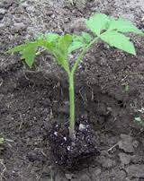

* Pest Control

Human hair is also known to address problems arising from many animals as well as insect pests, although by different mechanisms. Among large animals, it has been used to repel rabbits in Mauritius [24], rodents, and wild boar in India (author’s field discussions, [25]), and deer in the USA [26]. Typically, the hair is spread along the boundary of the fields/farms or near rat holes in the field. Rabbits, rodents, and wild boar find their food by sniffing, and hair supposedly causes them discomfort during sniffing by coming into their nostrils. In the case of deer, repulsion is supposedly caused by human smell emanating from the hair because hanging hair in nylon bags also works, and the technique does not seem to work well in the areas where deer are unafraid of humans. Among insects, human hair is used for deterring rhinoceros beetles in India [27, 28]. Small balls of human hair are placed at the nodes of the affected plant such as coconut tree. Beetles get tangled in the hair becoming unable to move. By using human hair mats, farmers in Florida (USA) were able to save ~$45,000 on pesticides on about 1 million plants in the year 2007 in addition to the labor savings and benefits as fertilizer [29].

* Composite Materials

Due to high tensile strength and high friction coefficient, human hair has been used for reinforcing clay-based constructions. In rural areas in Uttar Pradesh and Madhya Pradesh, India (author’s field discussions, [30]), Bangladesh [31], Syria [32], and in European countries [33], human hair/clay mixture (along with other binders) is used in plastering house walls, lining ovens, making wheels, and so forth. The addition of hair significantly reduces cracking and prolongs the life of these structures. Research shows that human hair reinforcement enhances the structural strength as well as the thermal insulation capacity of the clay structures [34, 35]. Although such clay-based constructions are now decreasing in rural areas, they are gaining importance in sustainable architecture.

   
 Fig 4 compose preparation

Human hair reinforcement also reduces cracks in cement mortar caused by plastic shrinkage by as much as 92% [36] and increases the compressive strength of fly ash/cement concrete by over three times [37]. This improved fracture-resilience and strength of hair-reinforced cement and fly ash concrete is highly useful in high-pressure-bearing structures such as petroleum wells and bridges. Any kind of hair can be used in these applications.

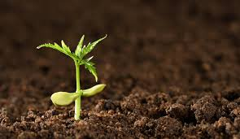

Fig 2 Compose for farming.

# CHAPTER SIX

## CONCLUSION

This study has shown that human hair has long been wasted in several ways by Barbers in Saki, which include burning, throwing away, damping in dust bins, burying etc. these pose deadly effects on us. i.e. Burning of human hair or the waste piles containing the shaved hair—a practice observed in many sub- localities of Saki —produces foul odor and toxic gases such as ammonia, carbonyl sulphides, hydrogen sulphides, sulphur dioxide, phenols, nitriles, pyrroles, and pyridines which when inhaled may cause severe lung cancer to many indigenes.

However, The human hair has a large number of uses in areas ranging from agriculture to medicine to engineering industries. It had been discovered also that the human hair can be of several tremendous use in the society. These uses include Separation and filtering of organic mixtures, Pharmaceuticals and Biomedical Applications, Suturing Material in Surgery, Scientific Instrumentation, Textiles, Fiber Stuffing, and Other Artifacts, Artwork, Test Material for Hair Care Products, as Composite Materials, for Pest Control etc. owing to address the need of the society and nation at large.

## RECOMMENDATION

With the help of the government, the public must be made aware of beneficial properties and safe practices of collection and use of the human hair.

‘Shaved- human- hair- collection’ policies should be made by government to ensure easy and save access to this valuable material various barbering shops.

With the aid of the government, a complete utilization/ recycling systems for human hair should be developed, this would help reduce solid waste and environmental problems, generate significant socioeconomic benefits for people, and reduce pressure on other nonrenewable materials and fossil fuels.

## REFERENCE

S. Kumar, J. K. Bhattacharyya, A. N. Vaidya, T. Chakrabarti, S. Devotta, and A. B. Akolkar, “Assessment of the status of municipal solid waste management in metro cities, state capitals, class I cities, and class II towns in India: an insight,” Waste Management, vol. 29, no. 2, pp. 883–895, 2009. View at Publisher · View at Google Scholar · View at Scopus

M. Brebu and I. Spiridon, “Thermal degradation of keratin waste,” Journal of Analytical and Applied Pyrolysis, vol. 91, no. 2, pp. 288–295, 2011. View at Publisher · View at Google Scholar · View at Scopus

UN Comtrade, Import values are based on HS2007 codes 050100, 670300, and 670420, 2012.

E. Vijayalakshmi, “Hair pollution hits Karnataka. Down to Earth,” 2003, http://www.downtoearth.org.in/node/13180.

M. Cohen, “India’s export of human hair to China is a booming business but it is also entangled in issues of respiratory diseases and child labor. The Standard,” 2007, http://www.thestandard.com.hk/news_detail.asp?pp_cat=31&art_id=50482&sid=14602467&con_type=3.

I. Malik, “Human hair trade: environmental hazards,” Tech. Rep., Vatavaran, New Delhi, India, 1998. View at Google Scholar

C. R. Robbins, Chemical and Physical Behavior of Human Hair, Springer, Heidelberg, Germany, 5th edition, 2012.

G. Biddle-Perry and S. Cheang, Eds., Hair: Styling, Culture, and Fashion, Berg, Oxford, UK, 2008.

M. Muto, T. Isobe, K. Ramu et al., “Contamination of Brominated Flame Retardants (BFRs) in human hair from e-waste recycling site in Vietnam,” in Interdisciplinary Studies on Environmental Chemistry—Environmental Pollution and Ecotoxicology, M. Kawaguchi, K. Misaki, H. Sato et al., Eds., pp. 229–237, 2012. View at Google Scholar

J. S. Cox, “The construction of an ancient Egyptian wig (c. 1400 B.C.) in the British Museum,” The Journal of Egyptian Archaeology, vol. 63, pp. 67–70, 1977. View at Publisher · View at Google Scholar

J. Turner, Brushes: A Handbook for Artists and Artisans, Design Books, 1992.

V. D. Zheljazkov, “Assessment of wool waste and hair waste as soil amendment and nutrient source,” Journal of Environmental Quality, vol. 34, no. 6, pp. 2310–2317, 2005. View at Publisher · View at Google Scholar · View at Scopus

M. Sharma, M. Sharma, and V. M. Rao, “In vitro biodegradation of keratin by dermatophytes and some soil keratinophiles,” African Journal of Biochemistry Research, vol. 5, no. 1, pp. 1–6, 2011. View at Google Scholar

AAA, “Ropes made of human hair,” Ann Arbor Argus, 1898, http://oldnews.aadl.org/node/153517.

L. Shiming, “The utilization of human excreta in Chinese agriculture and the challenge faced,” EcoSanRes, 2002, http://www.ecosanres.org/pdf_files/Nanning_PDFs/Eng/Luo%20Shiming%2010_C11rev.pdf .

P. Subbiah, “Human hair as fertilizer,” Communicator: Sathavu, M. Nam Vazhi Velanmai (Tamil Version of Honeybee), 1998.

P. Oudhia, “Revised version of selected Botanical.com articles,” Part 2, 2010, http://pankajoudhia.com/.

V. D. Zheljazkov, J. L. Silva, M. Patel et al., “Human hair as a nutrient source for horticultural crops,” HortTechnology, vol. 18, no. 4, pp. 592–596, 2008. View at Google Scholar · View at Scopus

J. Schaffer, “Urbanna Salon offers ‘Earth Hair’,” Down to Earth NW, 2011, http://www.downtoearthnw.com/stories/2011/jun/08/urbanna-salon-offers-earth-hair/.

A. Bhatta, “No hair-raising experience this,” Down to Earth, 2008, http://www.downtoearth.org.in/node/4928.

K. R. Yadav, R. K. Sharma, M. P. Yadav, and R. M. Kothari, “Human hair waste: an environmental problem converted into an eco-friendly plant tonic,” Fresenius Environmental Bulletin, vol. 4, no. 8, pp. 491–496, 1995. View at Google Scholar · View at Scopus

M. M. Rahman, “Fertilizer from hair!!,” ChE Thoughts, vol. 1, no. 1, pp. 20–21, 2010. View at Google Scholar

S. O. Oh, A. Yun, and D. H. Park, “Effects of physicochemically hydrolyzed human hairs on the soil microbial community and growth of the hot pepper plant,” Biotechnology and Bioprocess Engineering, vol. 16, no. 4, pp. 746–754, 2011. View at Publisher · View at Google Scholar · View at Scopus

S. Facknath and B. Lalljee, “Indigenous/traditional knowledge adopted in Mauritius for sustainable agriculture,” in Sustainable Agriculture: Issues in Production, Management, Agronomy, and ICT Applications, A. Bandopadhyay, K. V. Sundaram, M. Moni, P. S. Kundu, and M. M. Jha, Eds., pp. 147–164, Northern Books Center, New Delhi, India, 2005. View at Google Scholar

MOFF, Package of Organic Practices from Maharashtra for Cotton, Rice, Red Gram, Sugarcane and Wheat, Maharashtra Organic Farming Federation, Pune, India, 2006.

J. D. Scott and T. W. Townsend, “Methods used by selected Ohio growers to control damage by deer,” Wildlife Society Bulletin, vol. 13, no. 3, pp. 234–240, 1985. View at Google Scholar · View at Scopus

H. Siddhi, “Hair hinders rhinoceros beetle,” Honey Bee, vol. 8, no. 2, p. 8, 1997. View at Google Scholar

M. K. Deka, M. Bhuyan, and L. K. Hazarika, “Traditional pest management practices of Assam,” Indian Journal of Traditional Knowledge, vol. 5, no. 1, pp. 75–78, 2006. View at Google Scholar

T. F. Negrete, “Human hair market growing fast,” Herald Tribune, 2008, http://www.heraldtribune.com/article/20080106/NEWS/801060309.

C. S. Gupta, “Clay-traditional material for making handicrafts,” Indian Journal of Traditional Knowledge, vol. 7, no. 1, pp. 116–124, 2008. View at Google Scholar · View at Scopus

Abari, Rammed Earth Workshop, 2010, http://abari.org/rammed-earth-workshop.

N. M. Heymans, “Archaeology, experimental archaeology and ethnoarchaeology on bread ovens in Syria,” Civilizations, vol. 49, pp. 197–221, 2002. View at Google Scholar

P. Allen and N. May, “Clay plasters,” 2003, http://www.buildingconservation.com/articles/clayplaster/clayplaster.htm.

B. A. Jubran, S. M. Habali, M. A. S. Hamdan, and A. I. O. Zaid, “Some mechanical and thermal properties of clay bricks for the Jordan valley region,” Materials and Structures, vol. 21, no. 5, pp. 364–369, 1988. View at Publisher · View at Google Scholar · View at Scopus

R. R. Pillai and A. Ramanathan, “An innovative technique of improving the soil using human hair fibers,” in Proceedings of the 3rd International Conference on Construction in Developing Countries, pp. 4–6, Bangkok, Thailand, July 2012.

M. M. Al-Darbi, N. O. Saeed, L. O. Ajijolaiya, and M. R. Islam, “A novel oil well cementing technology using natural fibers,” Petroleum Science and Technology, vol. 24, no. 11, pp. 1267–1282, 2006. View at Publisher · View at Google Scholar · View at Scopus

J. N. Akhtar and S. Ahmad, “The effect of randomly oriented hair fiber on mechanical properties of fly-ash based hollow block for low height masonry structures,” Asian Journal of Civil Engineering, vol. 10, no. 2, pp. 221–228, 2009. View at Google Scholar · View at Scopus

R. M. Thompson, “Hair-based composite,” US Patent 20100178842A1, 2010.

Studio Swine, 2012, http://www.studioswine.com/hair-glasses.

D. P. Michael, S. Harish, A. Bensely, and D. M. Lal, “Insulation characteristics of sisal, human hair, coir, banana fiber composites at cryogenic temperatures,” Polymers from Renewable Resources, vol. 1, no. 1, pp. 47–56, 2010. View at Google Scholar

Z. V. P. Murthy, G. Kaushik, and R. Suratwala, “Treatment of oily water with human hair as a medium: a preliminary study,” Indian Journal of Chemical Technology, vol. 11, no. 2, pp. 220–226, 2004. View at Google Scholar · View at Scopus

B. D. McCrory and P. A. McCrory, “Device for containing and absorbing oil spills on water-,” US Patent 5453191, 1995.

E. Rodgers, “NASA tries hair-raising idea,” Aerospace Technology Innovation, vol. 6, no. 4, 1998, http://ipp.nasa.gov/innovation/Innovation64/hair.htm.

MSNBC, “Hairy idea: clippings used to absorb oil spills,” msnbc.com news service, 2006, http://www.msnbc.msn.com/id/14584306/ns/world_news-world_environment/t/hairy-idea-clippings-used-absorb-oil-spill/.

K. Gustafson, “How to clean the oil spill? Hair and mushrooms!,” 2010, earth911.com/news/2010/05/03/how-to-clean-the-oil-spill-hair-and-mushrooms/.

R. Ziemba, “Fungi vs. the BP oil spill,” 2010, http://www.inweekly.net/article.asp?artID=11629.

A. R. Talaie, M. Bagheri, S. Ghotbinasab, and M. R. Talaie, “Evaluation of formaldehyde wastewater adsorption on human hair,” Health Systems Research, vol. 6, no. 4, pp. 735–743, 2011. View at Google Scholar

F. A. Banat and S. Al-Asheh, “The use of human hair waste as a phenol biosorbent,” Adsorption Science and Technology, vol. 19, no. 7, pp. 599–608, 2001. View at Publisher · View at Google Scholar · View at Scopus

T. C. Tan, C. K. Chia, and C. K. Teo, “Uptake of metal ions by chemically treated human hair,” Water Research, vol. 19, no. 2, pp. 157–162, 1985. View at Publisher · View at Google Scholar · View at Scopus

S. S. Krishnan, A. Cancilla, and R. E. Jervis, “Waste water treatment for heavy metal toxins using plant and hair as adsorbents,” Science of the Total Environment, vol. 68, no. 1, pp. 267–273, 1988. View at Google Scholar · View at Scopus

D. Malliga, G. P. Jeyanthi, and V. Bhuvaneswari, “Adsorption of nickel(II) and chromium(VI) from synthetic metal solutions using powdered human hair as adsorbent,” Journal of Ecotoxicology and Environmental Monitoring, vol. 20, no. 1, pp. 39–50, 2010. View at Google Scholar

B. J. Ha, S. M. Kim, C. R. Kim, and O.-S. Jung, “Porous morphology and selective metal-adsorption of burned human hairs,” Bulletin of the Korean Chemical Society, vol. 31, no. 6, pp. 1459–1460, 2010. View at Publisher · View at Google Scholar · View at Scopus

Sigma-Aldrich, Prod. no. A7250, CAS no. 616-91-1, http://www.sigmaaldrich.com/etc/medialib/docs/Sigma-Aldrich/Product_Information_Sheet/a7250pis.Par.0001.File.tmp/a7250pis.pdf.

D. Winterman, “From food to fashion, the thriving market in human hair, BBC News Magazine,” 2010, http://news.bbc.co.uk/2/hi/uk_news/magazine/8753698.stm.

Abba Hair, http://www.hairproductstogo.com/abba.htm.

Joico Haircare, http://www.ariva.com/joico-k-pak-intense-hydrator.html.

E. Brand and N. Wiseman, Concise Chinese Materia Medica, Paradigm, 2008.

H. Xie, M. S. Kim, and C. Chrisman, “Herbs to stop bleeding,” in Xie’s Chinese Veterinary Herbology, H. Xie and V. Preast, Eds., Wiley-Blackwell, Ames, Iowa, USA, 2010. View at Google Scholar

S. K. Dash and S. Padhy, “Ethno-therapeutic importance of the human body—1. Medicaments of physical and physiological origins,” Studies on Ethno-Medicine, vol. 1, no. 1, pp. 55–58, 2007. View at Google Scholar

R. D. Forrest, “Early history of wound treatment,” Journal of the Royal Society of Medicine, vol. 75, no. 3, pp. 198–205, 1982. View at Google Scholar · View at Scopus

G. C. Sood, D. K. Sen, and L. D. Sota, “Human hair sutures in ophthalmic surgery,” British Journal of Ophthalmology, vol. 54, no. 5, pp. 335–337, 1970. View at Google Scholar · View at Scopus

I. Sri-Skanda-Rajah-Siva, “Autotrichograft sutures in cataract surgery,” British Journal of Ophthalmology, vol. 57, no. 2, pp. 138–143, 1973. View at Google Scholar · View at Scopus

T. V. Sivanandan, “A breakthrough in use of hair as suture material,” The Hindu, 2000, http://www.hindu.com/2000/07/13/stories/0413210n.htm.

L. Eroǧlu, E. Güneren, H. Akbaş, A. Demir, and A. Uysal, “Using human hair as suture material in microsurgical practice,” Journal of Reconstructive Microsurgery, vol. 19, no. 1, pp. 37–39, 2003. View at Google Scholar · View at Scopus

A. Nakamura, M. Arimoto, K. Takeuchi, and T. Fujii, “A rapid extraction procedure of human hair proteins and identification of phosphorylated species,” Biological and Pharmaceutical Bulletin, vol. 25, no. 5, pp. 569–572, 2002. View at Publisher · View at Google Scholar · View at Scopus

T. Fujii and Y. Ide, “Preparation of translucent and flexible human hair protein films and their properties,” Biological and Pharmaceutical Bulletin, vol. 27, no. 9, pp. 1433–1436, 2004. View at Publisher · View at Google Scholar · View at Scopus

Y. Hirao, K. Ohkawa, H. Yamamoto, and T. Fujii, “A novel human hair protein fiber prepared by watery hybridization spinning,” Macromolecular Materials and Engineering, vol. 290, no. 3, pp. 165–171, 2005. View at Publisher · View at Google Scholar · View at Scopus

V. Verma, P. Verma, P. Ray, and A. R. Ray, “Preparation of scaffolds from human hair proteins for tissue-engineering applications,” Biomedical Materials, vol. 3, no. 2, Article ID 025007, 2008. View at Publisher · View at Google Scholar · View at Scopus

S. Wang, F. Taraballi, L. P. Tan, and K. W. Ng, “Human keratin hydrogels support fibroblast attachment and proliferation in vitro,” Cell and Tissue Research, vol. 347, no. 3, pp. 795–802, 2012. View at Publisher · View at Google Scholar · View at Scopus

M.-C. Lenoir, B. A. Bernard, G. Pautrat, M. Darmon, and B. Shroot, “Outer root sheath cells of human hair follicle are able to regenerate a fully differentiated epidermis in vitro,” Developmental Biology, vol. 130, no. 2, pp. 610–620, 1988. View at Google Scholar · View at Scopus

A. Limat and T. Hunziker, “Use of epidermal equivalents generated from follicular outer root sheath cells in vitro and for autologous grafting of chronic wounds,” Cells Tissues Organs, vol. 172, no. 2, pp. 79–85, 2002. View at Publisher · View at Google Scholar · View at Scopus

B.-Y. Yoo, Y.-H. Shin, H.-H. Yoon, Y.-K. Seo, and J.-K. Park, “Hair follicular cell/organ culture in tissue engineering and regenerative medicine,” Biochemical Engineering Journal, vol. 48, no. 3, pp. 323–331, 2010. View at Publisher · View at Google Scholar · View at Scopus

J. Xu, C. Hu, Y. Ji, and S. Hu, “Ultrathin gold film deposited on human hair: derivation from nanoparticles and applications as microsensors,” Electrochemistry Communications, vol. 11, no. 4, pp. 764–767, 2009. View at Publisher · View at Google Scholar · View at Scopus

C. C. Trowbridge, “The use of the hair hygrometer,” Science, vol. 4, no. 81, pp. 62–65, 1896. View at Google Scholar · View at Scopus

N. T. T. Ha, D. K. An, P. V. Phong, P. T. M. Hoa, and L. H. Mai, “Study and performance of humidity sensor based on the mechanical-optoelectronic principle for the measurement and control of humidity in storehouses,” Sensors and Actuators B, vol. 66, no. 1, pp. 200–202, 2000. View at Publisher · View at Google Scholar · View at Scopus

O. G. Tod, The Joy of Handweaving, Dover, New York, NY, USA, 1977.

S. Amber, “How to recycle dog, cat, and human hair,” 2008, http://voices.yahoo.com/how-recycle-dog-cat-human-hair-860385.html.

G. K. Ghosh and S. Ghosh, Indian Textiles: Past and Present, APH, New Delhi, India, 1995.

“AnPing JinBoXin Garment Accessories Co.,” 2004, http://www.horse-hairfabric.com/horse-hair-fabric-horse-tail-lining/hair-interlining-fabric_2.htm>.

Todorovic, 2009, http://www.zorantodorovic.com/warmth.htm.

The Sunday Morning Star, “Human hair cloth used as oil filter,” Wilmingdon, Del, USA, 1926, http://news.google.com/newspapers?nid=VaBbNeojGYwC&dat=19260207.

H. H. Windsor, Ed., Long Ropes Made of Human Hair, Popular Mechanics Magazine, 1914.

L. S. M. Curtin, “Art and industries,” in By the Prophet of the Earth: Ethnobotany of the Pima, Reprinted 1984, University of Arizona Press, Tuscon, Ariz, USA, 1949. View at Google Scholar

T. Schumer, “Observations on the hair rope mecate,” High Minded Horseman, 2011, http://www.highmindedhorseman.com/2011/05/09/observations-on-the-hair-rope-mecate.

Chinaculture, “Hair embroidery,” Ministry of Culture, 2008, http://www1.chinaculture.org/library/2008-01/22/content_46519.htm.

Wenzhou Portrait Embroidery Institute, Zhejiang, China, http://www.wdfxw.com/en/about.asp.

S. Harran and J. Harran, 1997, http://www.hairwork.com/remember.htm.

H. Sheumaker, Love Entwined: The Curious History of Hairwork in America, University of Pennsylvania Press, Philadelphia, Pa, USA, 2007.

Victorian Hairwork Society, http://www.hairworksociety.org/.

C. Talavera-Gonzales, G. C. Lacia, C. V. Cipriano et al., Mapeh in Action II, Rex Book, Manila, Philippines, 2008.

A. L. Kishore, http://www.indiamart.com/alkishores/cutting-human-hairs.html.

P. Mehra, “Hair and how,” The Hindu, 2012, http://www.thehindu.com/news/cities/Delhi/article2897596.ece.

A. Rowland, The Human Hair, Popularly and Physiologically Considered with Special Reference to Its Preservation, Improvement and Adornment, and the Various Modes of Its Decoration in All Countries, Pipee Brothers, Cornell University Library, London, UK, 1853.

J. Greenwood, “The human hair market,” in In Strange Company: Being the Experiences of a Roving Correspondent, Henry S. King & Co., London, UK, 2nd edition, 1874. View at Google Scholar

A. E. Kramer, “For Russia’s poor, blonde hair is snippet of gold,” New York Times, 2010, http://www.nytimes.com/2010/11/22/business/global/22blond.html.

Indian Hair Industries, http://indianhairs.com/process.htm.

N. N. Srinivas, “Earn more $, just let your hair fall,” Economic Times, 2004, http://articles.economictimes.indiatimes.com/2004-09-18/news/27397334.

D. McDougall, “Trade in hair forces India’s children to pay the price,” The Observer, 2006, http://www.guardian.co.uk/world/2006/jun/25/india.theobserver.

A. Myers, “Portable material culture and death factory Auschwitz,” Papers from the Institute of Archaeology, vol. 18, pp. 57–69, 2007. View at Publisher · View at Google Scholar

N. Nelson, “Ministers refuse to stop imports of human hair taken from foreign prisoners and mental patients,” The People, 2011, http://www.people.co.uk/news/politics/2011/05/08.

A. Fisk, The human hair trade, http://adrianfisk.photoshelter.com/.

C. J. Bell, Answers to Questions about Old Jewellery, Krause, Iola, Wis, USA, 2009.

A. H. K. Topu, “Making a living with waste hair,” Star Insight, vol. 5, no. 33, 2011. View at Google Scholar

S. S. Gowd and B. Kotaiah, “Groundwater pollution by Cystine manufacturing industrial effluent around the factory,” Environmental Geology, vol. 39, no. 6, pp. 679–682, 2000. View at Google Scholar · View at Scopus

SEPA, “Announcement 25 by Ministry of Foreign Trade and Economic Cooperation, the General Administration of Customs and the State Environmental Protection Administration,” 2002, http://www.asianlii.org/cn/legis/cen/laws/cocftifbatfb655/.

Raj Hair Industries, http://www.rajimpex.com/about.htm.

S. Bates, “Orthodox Jews face wig ban after Hindu hair inquiry,” The Guardian, 2004.

H. Y. Belsky, “The Shaitel controversy,” Halacha Berurah, vol. 8, no. 3, pp. 1–7, 2005. View at Google Scholar

J. Flug, “A review of the recent sheitel controversy,” The Journal of Halacha and Contemporary Society, vol. 49, pp. 5–33, 2005. View at Google Scholar

D. Lindley, “New mats make gardening hair-raising,” China Daily, 2009, http://www.chinadaily.com.cn/business/2009-05/04/content_7740815.htm.

N. Zheng, CCTV International, 2004, http://www.cctv.com/news/financial/inland/20040104/100389_1.shtml.

L. Turner, “Human hair trade soars on celebrity hairdo envy,” Reuters, 2011, http://www.reuters.com/article/2011/08/03/us-human-hair-trade-idUSTRE7723U520110803.

Maps. google.com.gh

# CHAPTER SEVEN

## APPENDICES

### 3.1 QUESIONAIRE TO SOME BARBERS IN SAKI

1. How long have you worked here as a barber?

……………………………………………………………………………………………....……………………………………………………………………………………………………...……………………………..…………………..

2. Do you intend working here for long ?

…………………………………………………………………………………...................................................................................................................................................................................

3. How many customers do you get on an average day?

……………………………………………………………………………………………………………………….............................................................................................................................................

4. What do you use the shaved hair for?

……………………………………………………………………………………………………………………………………………...……………………………………………………………………………………………………….…….

### 3.2 GALLARY



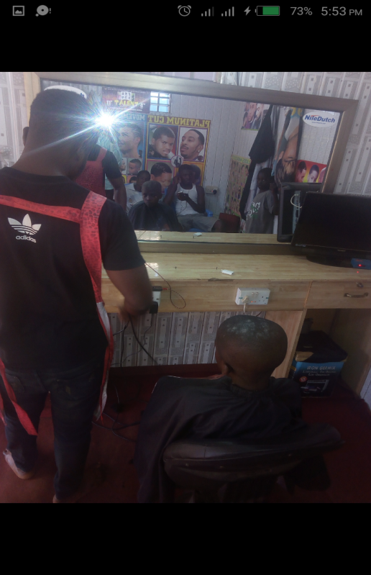

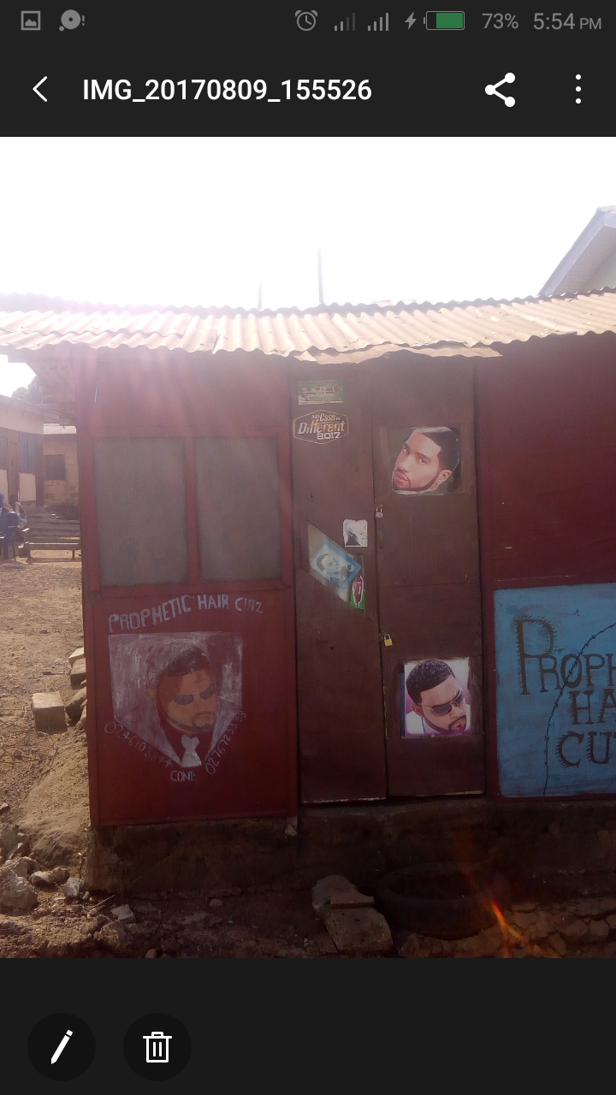

### 3.4 INTRODUCTORY LETTER

